Northam – July/Sept 2017
Master TreeGrower Course
Trees for land protection, shelter, wildlife, aesthetics, bush-food………& more
 | 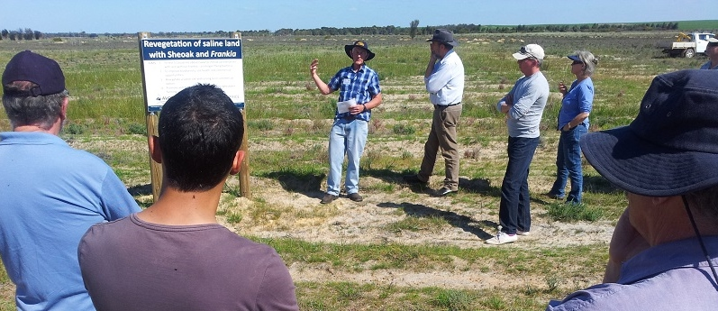
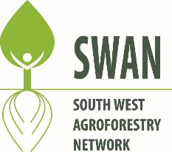 | Interested in using trees on your property? Australian Master TreeGrower courses provide some of the skills and contacts to enable you to use trees and revegetation to meet your particular interests and circumstances.  What: An 8-day course for landowners interested in trees for conservation and profit.
When: Day 1 Friday 28 July. Continues on Fri & Sat every fortnight. 9am start, finish by 4pm.
Where: Northam (venue to be confirmed)
Cost: $200 (ex GST) - a contribution to food & materials. DAY 1 is FREE - but RSVP
Format (it’s not your usual course):
- Morning presentations by experienced landowners, industry members and recognized experts covering topics of interest to participants.
 | - Afternoon tours to inspect and learn from local examples of trees and revegetation being managed by landowners. Tours include hands-on activities.
- Program is flexible and will be adapted to suit the interests of participants. The approach is non-prescriptive. It is recognized that everyone’s situation is unique.
Gear: Paid-up participants receive a MTG hat, MTG gate sign, tree measuring tape,
course notes, certificate and more.
The course is a joint project between the Australian Agroforestry Foundation, the South West Agroforestry Network and Wheatbelt NRM | Food: Lunches and morning/afternoon teas provided.  For more information or to register contact Richard Moore; mob. 0429 926 731  email. richard.w.moore2@gmail.com or http://www.swagroforestrynetwork.com.au/  or http://www.agroforestry.net.au/main.asp?_=Australian%20Master%20TreeGrower  See next page for more detail on dates, program and how to register.

 | 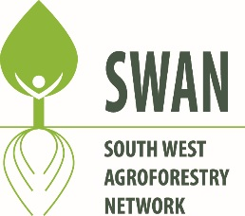 |  | Registration Form  Australian Master TreeGrower Course  Northam – July to Sept 2017
Tax Invoice – ABN 39 000 694 904
Cost: $200 (incl. GST), includes course materials and lunches
Day |  | Date | Main topics
1 |  | Fri 28 July | Introduction, multi-purpose tree growing, field visit to local examples
2 |  | Sat 29 July | Markets for tree products, environmental services from trees, field tour
3 |  | Fri 11 August | Tree and forest measurement, field exercise
4 |  | Sat 12 August | Tree establishment, growth and management, field visit to local examples
5 |  | Fri 25 August | Integrating trees with farming – local examples
6 |  | Sat 26 August | SW Agroforestry Network field day, managing native bush and more
7 |  | Fri 8 Sept | Integrating trees into rural landscapes, trees for aesthetics
8 |  | Sat 9 Sept | Economic aspects of tree growing, partners in trees and revegetation
Start time each day - 9.00am. Usual finish time - 4.00pm. Participants are encouraged to attend all days.
Venue: Northam, actual venue to be confirmed
Name(s):………………………………………………………………………………………………………………………………….
Address:…………………………………………………………………………………………………………………………………..
Phone:………………………………………………………..….Mob:………………………………………………………………….
Email…………………………………………………………………………………………………………………….........................
Property location/size:………………………………………...Type:……………………………………………………………..….
Special dietary requirements:………………………………………………………………………………………………………….
Topic(s) you’d like covered in the course:…………………………………………………………………………..........................
Making payment of $200: (If cost is a barrier please discuss.)
Internet: Direct debit to Australian Forest Growers, BSB: 032-722, Account No. 111673
Please state name and “Northam MTG” when paying
Cheques: Make payable to Australian Forest Growers and post to Richard Moore,
Australian Forest Growers SW, 341 Yungarra Drive, Quedjinup, WA, 6281
Submitting registration form:
Email to richard.w.moore2@gmail.com OR post to Richard Moore, 341 Yungarra Drive, Quedjinup, WA, 6281
For more information:
Contact Richard Moore, mob. 0429 926 731 or email; richard.w.moore2@gmail.com
Or visit http://www.swagroforestrynetwork.com.au/ or
http://www.agroforestry.net.au/main.asp?_=Australian%20Master%20TreeGrower

